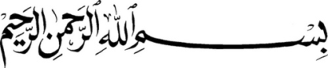

NIKKAH:

After Maghrib

With Best Compliments:

Dr. Syed Maqdoom M. Quadri

Syed Noman Jameel

Azeemullah Hussaini Syed

Mrs. & Dr. Syed Tajuddin Quadri

Mrs. Syed Ghouse Mohiuddin Quadri

request the honor of your presence & blessings on the auspicious occasion of the

Nikkah of their Granddaughter

Ismat Quadri

(B.S. -Nutritionist USA)

D/O Mrs. & Mr. Aladin Syed Quadri

(Retired Secretary Saudi Arabian Airlines)

With

Syed Yameenuddin

(M.B.A.)

S/O Mrs. & Mr. Syed Ifteqharuddin Faheem

In’shaa’Allah

On

21st January, 2013 (Monday) " 8th Rabi-ul-Awal 1434 Hijri "

At

Masjid-e-Osmania near Judges Colony Malakpet,

Hyderabad, A.P. India

Dinner Follows at

Vijay Gardens

Garden Street, Champapet, Sagar Road,

Hyderabad, A.P. India 500059